SIT123: Data Capture Technologies

# Sensing Temperature and Humidity Activity Sheet

## Hardware Required

* Arduino Board
* USB cable
* DHT22 Temperature and Humidity Sensor (<https://tronixlabs.com.au/sensors/humidity/dht22-temperature-and-humidity-sensor-australia/> )
* Male to Female Dupont Jumper Wires

## Pre-requisites: You must do the following before this task

**Read this sheet from top to bottom**

## Steps

1. Connect your DHT22 Temperature and Humidity Sensor to the Arduino board. Refer to the images included below for guidance. 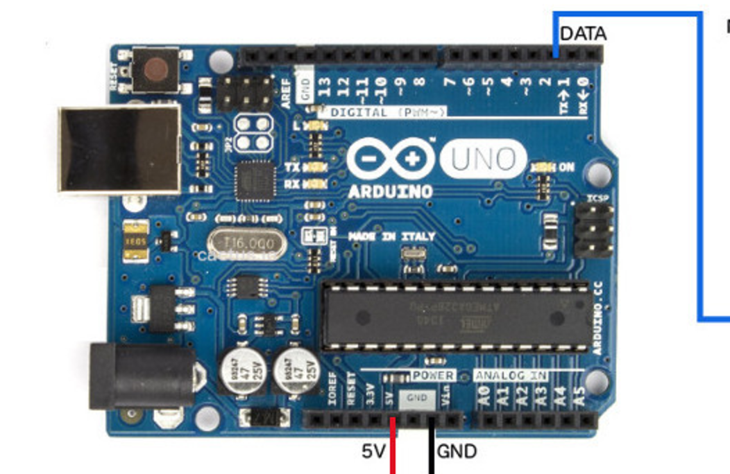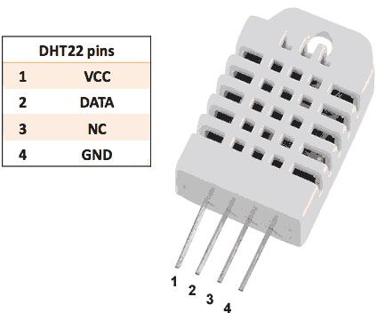
   1. Pick a red male-female jumper wire and attach the female end to pin 1 (VCC pin) on the sensor. Plug the male end into the Arduino board’s 5V power pin.
   2. Pick a blue male-female jumper wire and attach the female end to pin 2 (DATA pin) on the sensor. Plug the male end into the Arduino board’s digital data pin 2.
   3. Pick a black male-female jumper wire and attach the female end to pin 4 (GND) on the sensor. Plug the male end into the Arduino board’s GND pin.
   4. Sensor’s pin 3 is not used.
2. Connect your Arduino board to your computer using the USB cable.
3. Open your Arduino IDE
4. Go to <https://github.com/adafruit/DHT-sensor-library> and download the library to your computer by clicking ‘Download ZIP’.

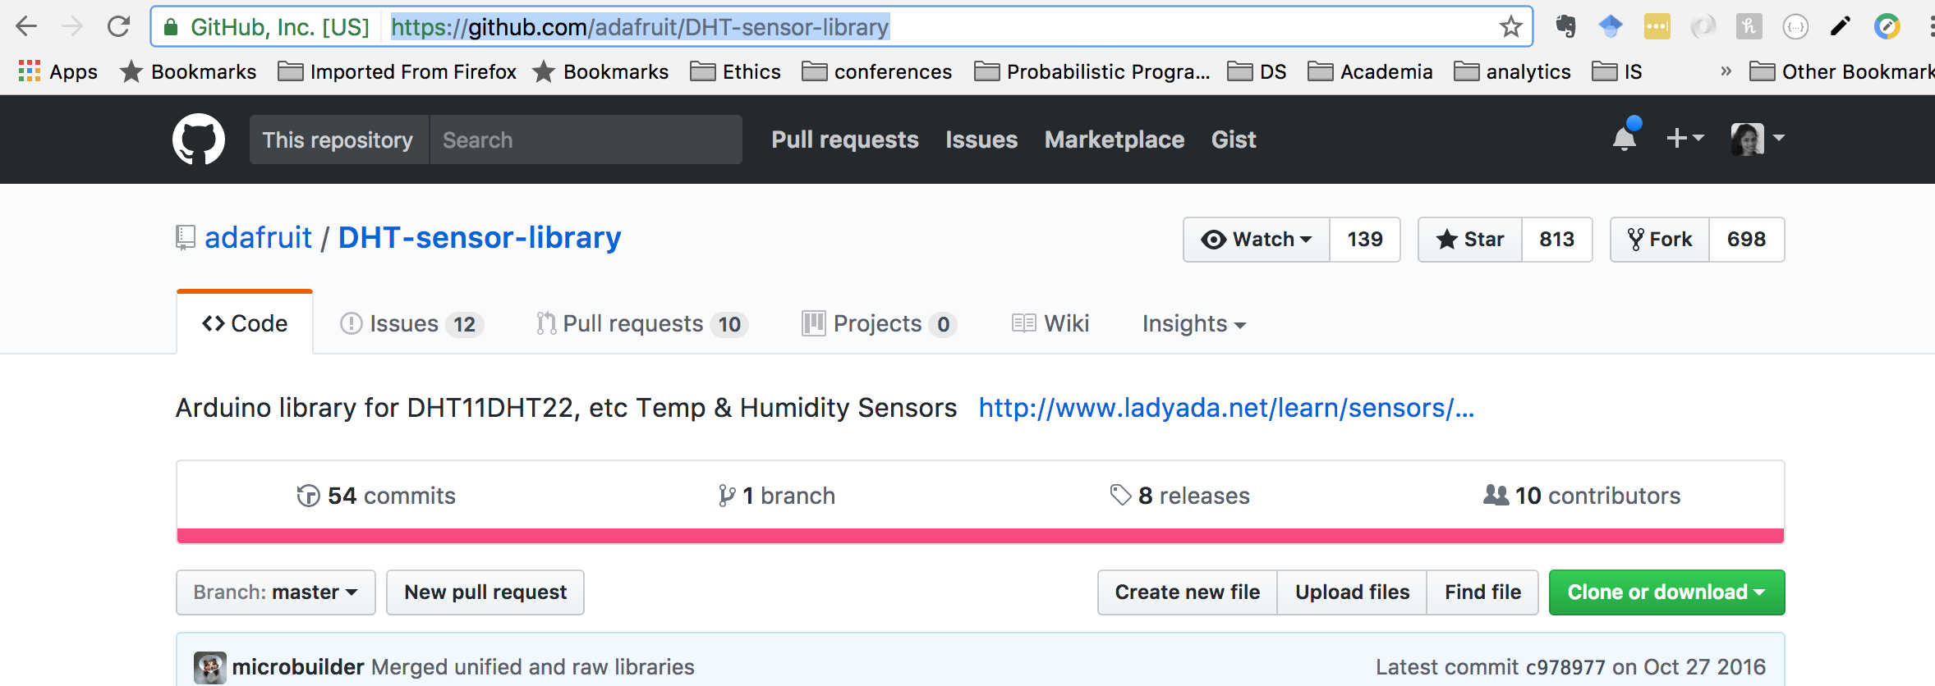

1. The .zip file you just downloaded is an external library. These have implemented functionality for DHT series of low cost temperature/humidity sensors. Using external libraries can save us from ‘reinventing the wheel’!.
2. Save the downloaded library. You should save all your Arduino libraries in one location, such as inside Documents/Ardiuno/Libraries
3. Go to <https://github.com/adafruit/Adafruit_Sensor> and download the library to your computer by clicking ‘Download ZIP’. Save it inside Documents/Ardiuno/Libraries
4. Download the provided code at https://github.com/FeifeiDeakin/DHT22tempHum. If you download it in .zip format, you must extract it to a location on your computer after you download it.

See: <https://support.microsoft.com/en-us/help/14200/windows-compress-uncompress-zip-files> for extracting zip files on Windows &

<https://support.apple.com/kb/PH25411?locale=en_US> for extracting zip files on Macs.

1. Go to the Arduino IDE. Select “File -> Open” and it will open a dialog box.

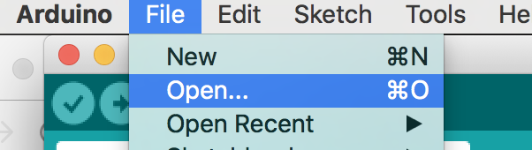

1. Select the DHT22tempHum.ino file inside the DHT22tempHum folder & click Open.

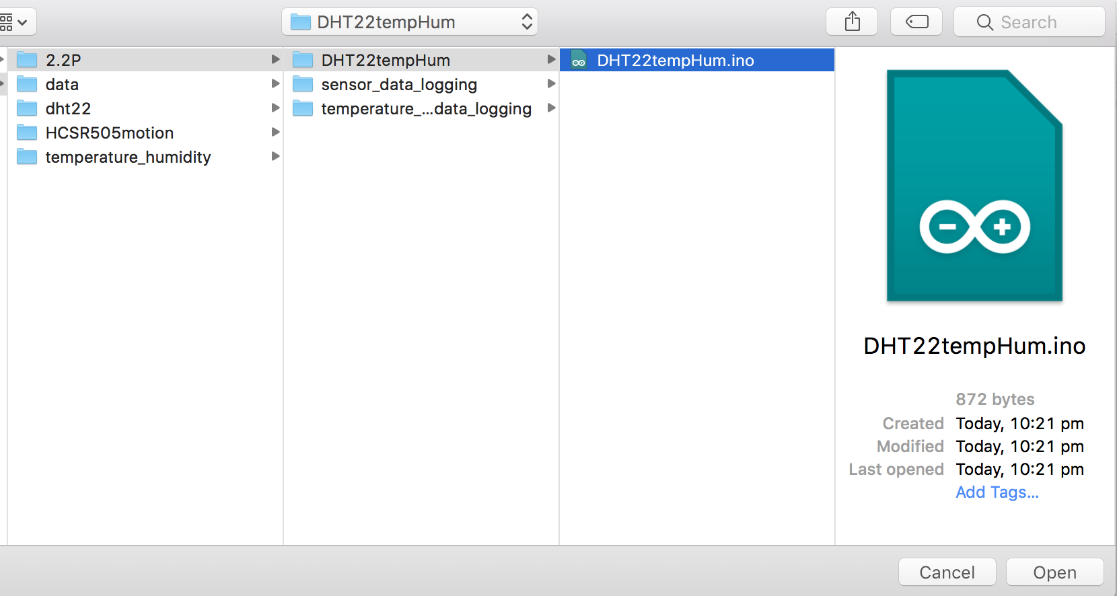

1. Add the libraries you downloaded to Arduino by selecting Sketch->Include library>Add Zip library. Select the downloaded zip libraries.

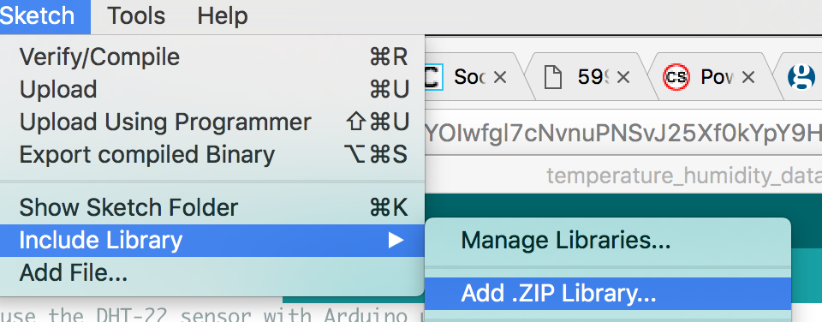

1. In your Arduino IDE, click on the ‘Verify’ button. This will check for errors and compile your code.
2. Use the “tools” menu to check the port to which the Arduino board is connected. Once the right port is selected, it is possible to upload sketches to Arduino.
3. Now click the upload icon to upload the code to the Arduino board. If you get an error, check to be sure you’ve selected the correct device and port. Screen Shot 2017-05-22 at 10.36.32 am.png
4. Open the Serial Monitor in the Arduino IDE by selecting Tools->Serial Monitor, or by clicking on the Serial Monitor icon.
5. Observe what’s printed on the Serial Monitor!

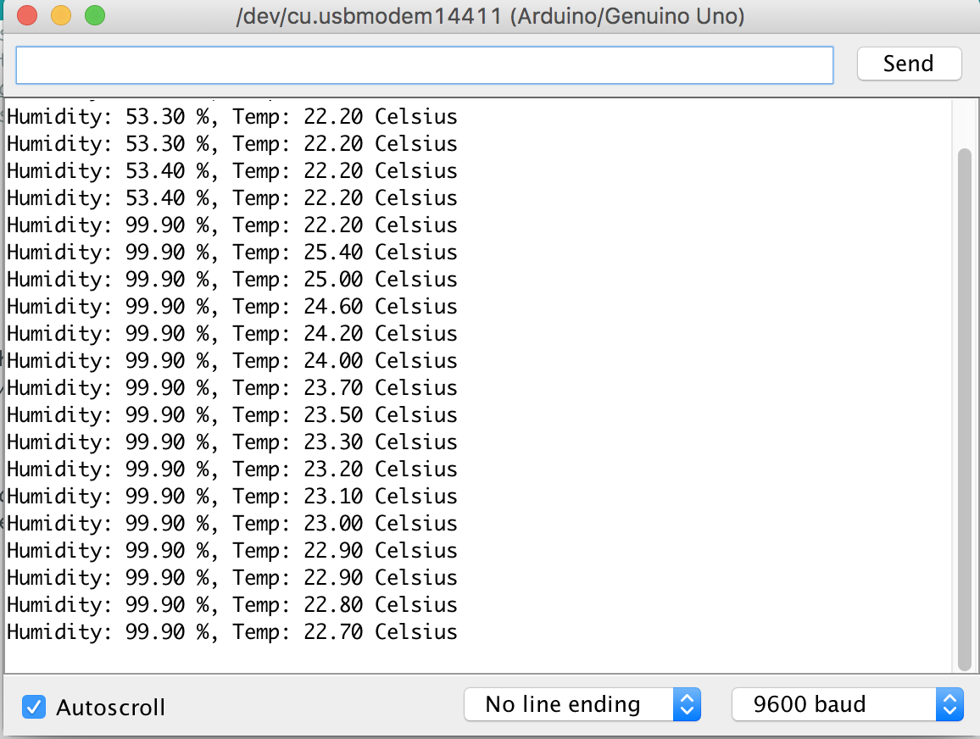

## 

## References

<https://github.com/adafruit/RTClib>

<https://learn.adafruit.com/adafruit-data-logger-shield/using-the-real-time-clock-3>

<http://www.instructables.com/id/How-to-use-DHT-22-sensor-Arduino-Tutorial/>

<https://plot.ly/arduino/dht22-temperature-tutorial/>

<http://cactus.io/hookups/sensors/temperature-humidity/dht22/hookup-arduino-to-dht22-temp-humidity-sensor>